THE UNIVERSITY OF AZAD JAMMU AND KASHMIR
Department of Software Engineering

DIGITAL IMAGE PROCESSING LAB
Lab Task 03
Image Enhancement and Intensity Transformations
Student Name | KHADIJA HASSAN
Roll No. | 2024-SE-09
Course | Digital Image Processing Lab
Lab Instructor | Engr. Fahad Nisar
Semester / Session | Fifth / 2024-28 (SE)
Assigned On | November 02, 2026
Due Date | November 09, 2026, 11:59 PM
Deliverables | This report (.docx) + notebook (.ipynb) + input image

1. Objective, Environment and Image
Objective. To calculate, implement and compare grayscale intensity transformations, histogram enhancement and thresholding, while preventing overflow and interpreting their effects. For every operation a dry run (hand calculation on a few pixels) is shown and then verified in Python, followed by the same operation on a real image and a comparison with the original.
Environment and input image
Item | Value
Tools | Python 3, Jupyter Notebook (.ipynb), NumPy, OpenCV 4.13, Matplotlib
Input image | input_image.png (colour poster image; converted to 8-bit grayscale on loading with cv2.IMREAD_GRAYSCALE)
Shape | (1041, 736) → 1041 rows × 736 columns (≥ 300 × 300 ✔)
Data type | uint8
Minimum / Maximum | 0 / 255
Original kept unchanged | Array set read-only; MD5 fingerprint verified after all experiments ✔
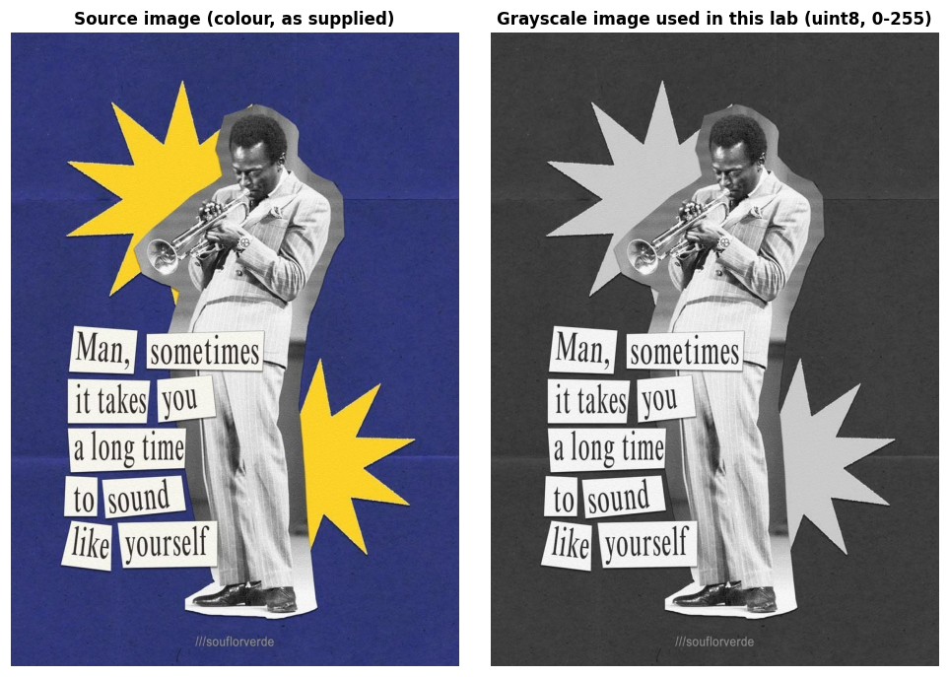
Figure 1 — Source image (left) and the 8-bit grayscale version used for all experiments (right).

Numeric safety: overflow and clipping
A uint8 value can only hold 0–255. Arithmetic done inside uint8 wraps around modulo 256, so the safe recipe used for every operation is widen → compute → clip to 0–255 → convert to uint8 (fractional results are truncated unless rounding is requested).
Input r | 30 | 80 | 128 | 180 | 240
Naive uint8: r + 40 | 70 | 120 | 168 | 220 | 24 ✘ (280 wraps)
Safe: int16, clip, uint8 | 70 | 120 | 168 | 220 | 255 ✔

Task 1 — Brightness Adjustment
Formula: s = r + β, with β = +40 (brighter) and β = −40 (darker).
Method: to_uint8(original.astype(int16) ± 40); the +40 case is also implemented with nested loops and compared with NumPy.

Dry run 1 — pixels [30, 80, 128, 180, 240]
r | r+40 raw | clipped | uint8 | r-40 raw | clipped | uint8
30 | 70 | 70 | 70 | -10 | 0 | 0
80 | 120 | 120 | 120 | 40 | 40 | 40
128 | 168 | 168 | 168 | 88 | 88 | 88
180 | 220 | 220 | 220 | 140 | 140 | 140
240 | 280 | 255 | 255 | 200 | 200 | 200

✔ Verified in Python: +40 → [70, 120, 168, 220, 255]; −40 → [0, 40, 88, 140, 200] — identical to the hand calculation.

Observation / lost detail. The raw value of 240 + 40 = 280 exceeds 255 and is clipped to 255; the raw value of 30 − 40 = −10 is below 0 and is clipped to 0. Clipping is the only place detail is lost: after +40 every original level from 215 to 255 collapses to 255 (41 different intensities become one), and after −40 every level from 0 to 40 collapses to 0. The un-clipped dry-run pixels keep their exact differences (e.g. 80 → 120 and 128 → 168 are still 48 apart), i.e. brightness shifts values but does not change differences between pixels that are not clipped.

Image results
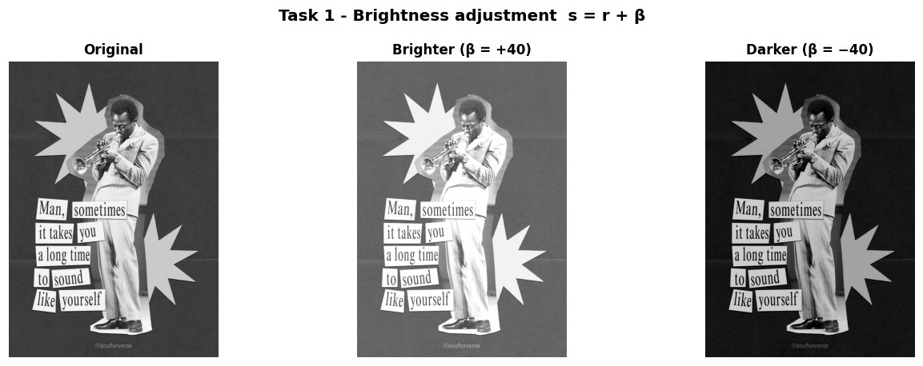
Figure 2 — Original, brighter (β = +40) and darker (β = −40).
Observations
- β = +40 raised the mean intensity from 107.23 to 143.91; β = −40 lowered it to 67.36. Each shift is ±40 apart from the effect of clipping.
- Detail is lost at the ends: 14.16 % of the pixels were saturated by +40 (the white paper labels, the light star and the light suit lose their texture and merge into pure white), whereas only 1.31 % were crushed to black by −40, because this image has very few pixels below 40.
- The nested-loop version (explicit int() conversion + if clipping) is pixel-for-pixel identical to the vectorised NumPy result (0 differing pixels), confirming the vectorised code while being far faster.

Task 2 — Linear Contrast from Zero
Formula: s = αr + β with α = 1.5 and β = 0.
Method: to_uint8(1.5 * original.astype(float64)) (clip, then truncate).

Dry run 2 — pixels [30, 80, 128, 180, 240]
r | 1.5 r (raw) | clipped 0-255 | truncated uint8 | saturated?
30 | 45 | 45 | 45 | No
80 | 120 | 120 | 120 | No
128 | 192 | 192 | 192 | No
180 | 270 | 255 | 255 | Yes (>255)
240 | 360 | 255 | 255 | Yes (>255)

✔ Verified in Python: 1.5 r → [45, 120, 192, 255, 255]; saturated pixels are 180 and 240.

Observation. For pixels 30, 80 and 128 the multiplication gives 45, 120 and 192 (all below 255), so their differences grow by 1.5×. Pixels 180 (raw 270) and 240 (raw 360) both exceed 255 and become 255, so the 60-level gap between them is lost (saturated pixels: 180 and 240). Because multiplication scales from 0, the whole image also gets brighter, and every input ≥ 170 is saturated.

Image results
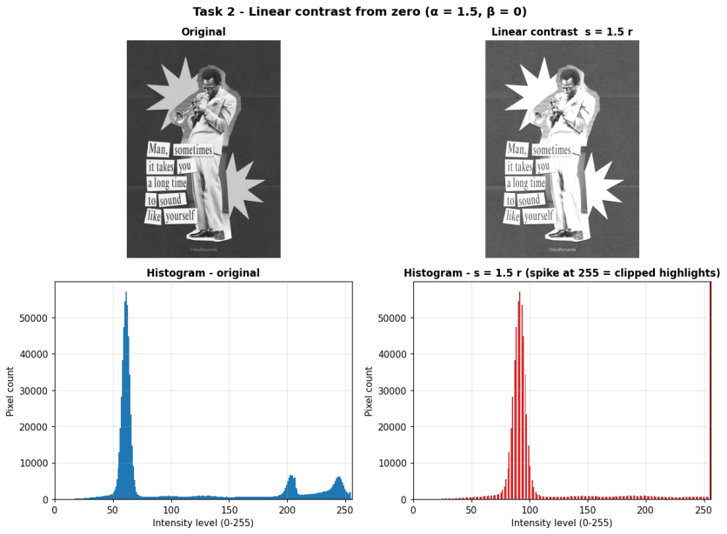
Figure 3 — Original vs s = 1.5 r with their histograms (note the spike at 255 = clipped highlights).
Observations (comparison with the original)
- Brightness: the mean rose from 107.23 to 140.98; the large dark background peak moved from about level 61 to about 92 (1.5 × 61), so the background looks lighter and flatter.
- Highlight clipping: pixels at 255 jumped from 0.03 % to 25.93 % (every original value ≥ 170 saturates). This is the tall spike at 255 in the histogram: the labels, stars and suit highlights lose all internal detail.
- The spread grows only slightly (std 70.85 → 73.78) because clipping removes the upper end of the stretch. Linear contrast from zero therefore cannot raise contrast without also changing brightness, and 0 stays 0 so shadows are not separated any better.

Task 3 — Contrast Centred at 128
Formula: s = (r − 128)·α + 128, with α = 1.5 and α = 0.5.
Method: float64 arithmetic around the pivot 128, then clip and truncate.

Dry run 3 — pixels [30, 80, 128, 180, 240]
α = 1.5
r | r-128 | x1.5 | +128 (raw) | clipped | uint8
30 | -98 | -147 | -19 | 0 | 0
80 | -48 | -72 | 56 | 56 | 56
128 | 0 | 0 | 128 | 128 | 128
180 | 52 | 78 | 206 | 206 | 206
240 | 112 | 168 | 296 | 255 | 255
α = 0.5
r | r-128 | x0.5 | +128 (raw) | clipped | uint8
30 | -98 | -49 | 79 | 79 | 79
80 | -48 | -24 | 104 | 104 | 104
128 | 0 | 0 | 128 | 128 | 128
180 | 52 | 26 | 154 | 154 | 154
240 | 112 | 56 | 184 | 184 | 184

✔ Verified in Python: α = 1.5 → [0, 56, 128, 206, 255]; α = 0.5 → [79, 104, 128, 154, 184]. At r = 128 the output is 128 for every α.

Observation. With α = 1.5 the outputs are 0 (raw −19, clipped), 56, 128, 206 and 255 (raw 296, clipped): differences are stretched around 128 and both extremes clip. With α = 0.5 the outputs are 79, 104, 128, 154 and 184: all values are pulled toward 128 and nothing clips. At r = 128 the result is 128 for every α, because (128 − 128)·α + 128 = 128 — 128 is the pivot (fixed point), so mid-gray is neither brightened nor darkened, unlike s = αr where 128 moves to 192 (α = 1.5).

Image results
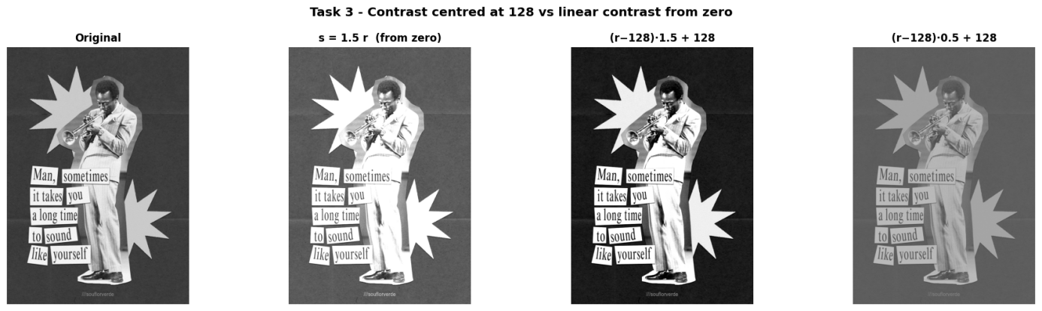
Figure 4 — Centred contrast (α = 1.5 and 0.5) compared with linear contrast from zero.
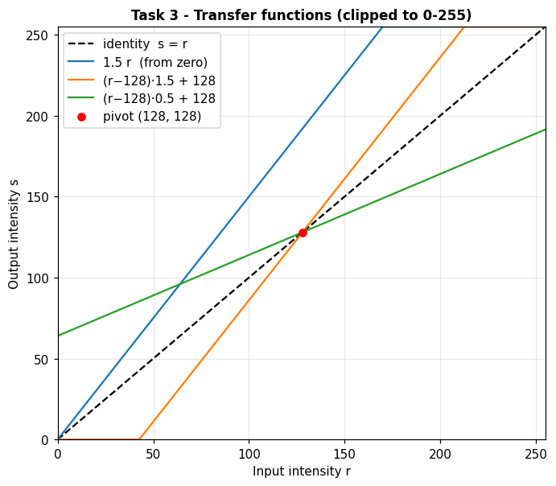
Figure 5 — Transfer functions: the centred curves all pass through the pivot (128, 128).
Image | Mean | Std dev | % at 0 | % at 255
Original | 107.23 | 70.85 | 0.00 | 0.03
s = 1.5 r (from zero) | 140.98 | 73.78 | 0.00 | 25.93
Centred, α = 1.5 | 91.40 | 96.15 | 1.77 | 14.65
Centred, α = 0.5 | 117.37 | 35.43 | 0.00 | 0.00
Observations (compared with linear contrast from zero)
- Mean brightness: s = 1.5r raised the mean from 107.23 to 140.98, whereas centred contrast keeps it near the pivot. With α = 1.5 the mean even fell to 91.40 because most of this image (at least 65 % of the pixels) is darker than 128 and is pushed further down (background level 61 → 27.5); with α = 0.5 the mean is 117.37 (background 61 → 94.5).
- Contrast: α = 1.5 raises the std from 70.85 to 96.15 (more than the 73.78 of 1.5r) but clips at both ends: 14.65 % of pixels go to 255 and 1.77 % to 0. α = 0.5 halves the spread (std 35.43), giving a flat, washed-out image with no clipping.
- The transfer-function plot shows why: the centred lines pass through (128, 128), while 1.5r rotates about the origin.

Task 4 — Image Negative
Formula: s = 255 − r.
Method: to_uint8(255 − original.astype(int16)).

Dry run 4 — pixels [30, 80, 128, 180, 240]
r | 255 - r | 255 - (255 - r) | equals original?
30 | 225 | 30 | Yes
80 | 175 | 80 | Yes
128 | 127 | 128 | Yes
180 | 75 | 180 | Yes
240 | 15 | 240 | Yes

✔ Verified in Python: Negative → [225, 175, 127, 75, 15]; negative of the negative equals the original exactly.

Observation. 255 − r gives 225, 175, 127, 75, 15; applying it again returns 30, 80, 128, 180, 240 — exactly the original. The negative is therefore a lossless, self-inverse transform (no clipping can occur because 0 ≤ r ≤ 255). The mid-gray 128 maps to 127, almost itself.

Image results
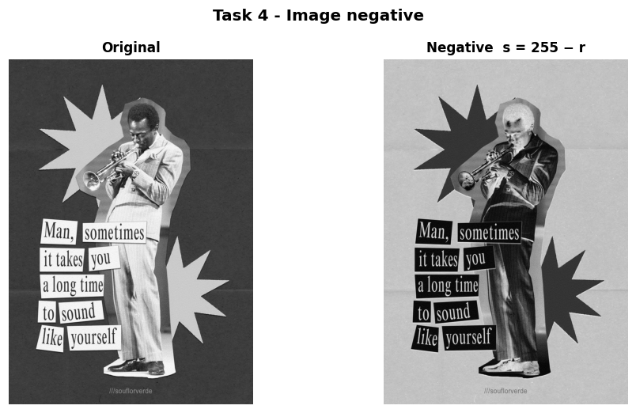
Figure 6 — Original and its negative.
Observations
Observations. The negative reverses dark and light (mean 107.23 → 147.77; the two means add up to exactly 255): the dark blue-gray background becomes light, and the figure, labels and stars become dark. Applying the negative twice reproduces the original exactly (True).
Where it helps inspection: in medical imaging (e.g. X-rays or mammograms), small bright structures on a dark background — such as fine fractures or micro-calcifications — are often easier to judge when shown as dark details on a light background. The same idea helps with scanned film negatives and with light text on a dark background (like the white labels here).

Task 5 — Gamma Correction
Formula: s = 255·(r/255)^γ, with γ = 0.5 and γ = 2.0. Convention: γ < 1 brightens, γ > 1 darkens.
Method: 256-entry look-up table computed in float64; only the final value is truncated.

Dry run 5 — pixels [0, 64, 128, 192, 255]
γ = 0.5
r | r/255 | (r/255)^0.5 | x 255 | truncated uint8
0 | 0.000000 | 0.000000 | 0.0000 | 0
64 | 0.250980 | 0.500979 | 127.7498 | 127
128 | 0.501961 | 0.708492 | 180.6654 | 180
192 | 0.752941 | 0.867722 | 221.2691 | 221
255 | 1.000000 | 1.000000 | 255.0000 | 255
γ = 2.0
r | r/255 | (r/255)^2.0 | x 255 | truncated uint8
0 | 0.000000 | 0.000000 | 0.0000 | 0
64 | 0.250980 | 0.062991 | 16.0627 | 16
128 | 0.501961 | 0.251965 | 64.2510 | 64
192 | 0.752941 | 0.566920 | 144.5647 | 144
255 | 1.000000 | 1.000000 | 255.0000 | 255

✔ Verified in Python: γ = 0.5 → [0, 127, 180, 221, 255]; γ = 2.0 → [0, 16, 64, 144, 255].

Observation. γ = 0.5 lifts the dark and mid tones (64 → 127, 128 → 180, 192 → 221) while 0 and 255 stay fixed; γ = 2.0 pushes them down (64 → 16, 128 → 64, 192 → 144). Intermediate values were kept at full precision and only the final result was truncated.
Difference from the rounded slide example. If normalised values are rounded to 0.25, 0.5 and 0.75 (instead of the true 64/255 = 0.25098, 128/255 = 0.50196, 192/255 = 0.75294) and the output is rounded rather than truncated, small differences appear — as the check printed above shows: for γ = 0.5 the rounded method gives 128 where full precision gives 127.7498 → 127, and for γ = 2.0 it gives 143 where full precision gives 144.5647 → 144. The causes are (1) rounding the normalised input and (2) rounding instead of truncating the final value; the differences are at most one gray level.

Image results
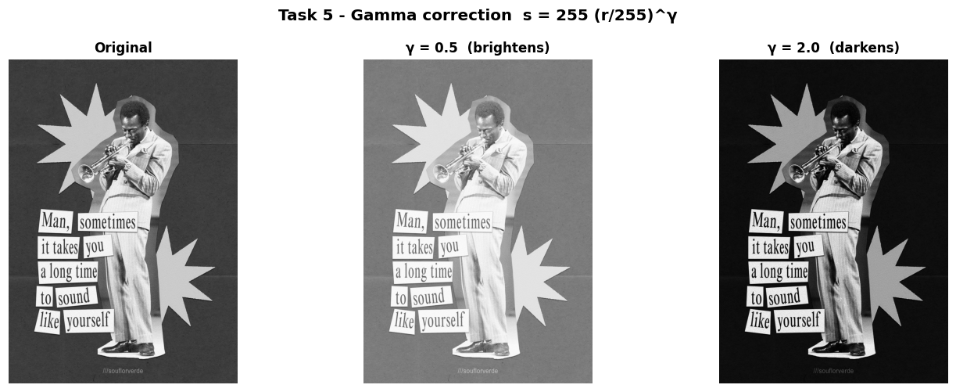
Figure 7 — Original, γ = 0.5 (brightens) and γ = 2.0 (darkens).
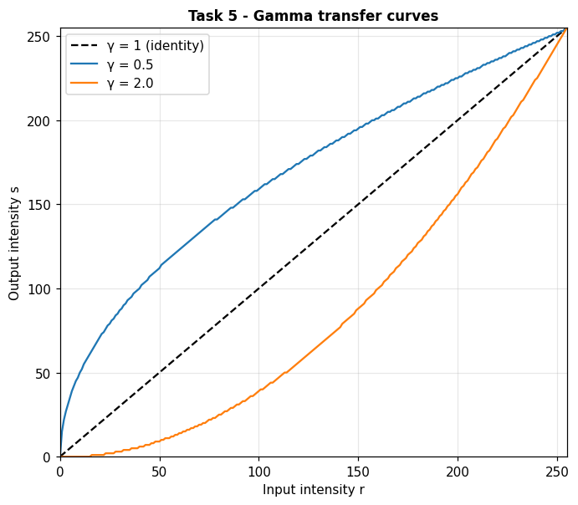
Figure 8 — Gamma transfer curves (0 and 255 stay fixed).
Observations
- Dark regions: 52.0 % of the pixels have r < 64 (essentially the paper-textured background). Their mean intensity is 58.33 originally, 121.11 with γ = 0.5 (the paper texture and fold lines in the background are expanded into the visible range) and only 13.07 with γ = 2.0 (the background and its texture are crushed almost to black).
- Overall mean: 107.23 → 156.92 (γ = 0.5) and 64.37 (γ = 2.0). With γ = 0.5 the bright labels are compressed towards white, with γ = 2.0 the mid-tones of the figure darken.
- Confirmed: the look-up tables map 0 → 0 and 255 → 255 for both γ values. Unlike +β brightness, gamma does not clip, because the curve stays inside 0–255 and changes tones non-linearly.
- Convention: here γ < 1 brightens and γ > 1 darkens (s = 255(r/255)^γ).

Task 6 — Grayscale Histogram
Definitions: h(k) = number of pixels with intensity k; p(k) = h(k)/N.
Method: np.hist(img.ravel(), bins=256, range=(0, 256)), cross-checked with cv2.calcHist.

Dry run 6 — A = [[0, 50, 50, 100], [100, 150, 200, 255]]
intensity | frequency | probability
0 | 1 | 1/8 = 0.125
50 | 2 | 2/8 = 0.250
100 | 2 | 2/8 = 0.250
150 | 1 | 1/8 = 0.125
200 | 1 | 1/8 = 0.125
255 | 1 | 1/8 = 0.125

✔ Verified in Python: Total N = 8, six non-zero bins, probabilities sum to 1; a shuffled copy of A has an identical histogram.

Observation. The 8 pixels fall into 6 non-zero bins: 0 (1), 50 (2), 100 (2), 150 (1), 200 (1), 255 (1); probabilities 0.125, 0.25, 0.25, 0.125, 0.125, 0.125 sum to 1. All other 250 bins are empty.
Why a histogram does not show pixel positions. A histogram only counts how many pixels have each intensity and discards where they are. The shuffled copy of A has exactly the same histogram, and so would any two completely different images (e.g. a photograph and a random scramble of its pixels) that have the same intensity counts.

Image results
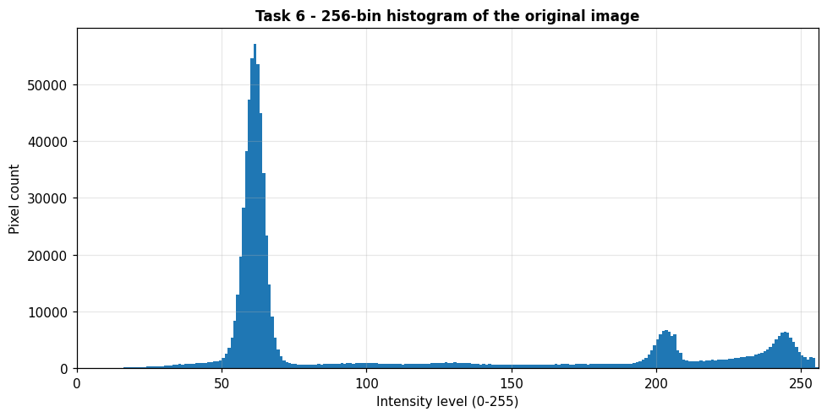
Figure 9 — 256-bin histogram of the original image.
Observations
Interpretation (two sentences). The histogram is dominated by one very tall, narrow peak at level 61 (about 65 % of the pixels lie in 0–84; this is the dark background), with only two small bright peaks near 203 and 244 and an almost empty, flat mid-range between them (about 9 % of the pixels). The image is therefore overall dark with a very wide intensity range (5th–95th percentile = 54–244) but a strongly bimodal, sharply separated dark/bright structure, with almost no clipping at 255.

Task 7 — Global Histogram Equalization
Mappings: s = 255·CDF and s = 255·(CDF − CDFmin)/(1 − CDFmin) (rounded to nearest, .5 upward).
Method: cv2.equalizeHist(original).

Dry run 7 — pixels [50, 50, 100, 150]
intensity | frequency | cumulative | CDF | 255 x CDF | 255(CDF-CDFmin)/(1-CDFmin)
50 | 2 | 2 | 0.5 | 127.50 -> 128 | 0.00 -> 0
100 | 1 | 3 | 0.75 | 191.25 -> 191 | 127.50 -> 128
150 | 1 | 4 | 1 | 255.00 -> 255 | 255.00 -> 255

Mapping | Output list for [50, 50, 100, 150]
1: 255 × CDF | [128, 128, 191, 255]
2: 255 × (CDF − CDFmin)/(1 − CDFmin) | [0, 0, 128, 255]
OpenCV cv2.equalizeHist | [0, 0, 128, 255] ← identical to mapping 2

✔ Verified in Python: Mapping 2 equals the output of cv2.equalizeHist.

Observation. Frequencies: 50 → 2, 100 → 1, 150 → 1; cumulative counts 2, 3, 4; CDF 0.5, 0.75, 1.0 and CDFmin = 0.5.
- Mapping 1 (255 × CDF): 127.5 → 128, 191.25 → 191, 255 → 255, so the output list is [128, 128, 191, 255].
- Mapping 2 (255 × (CDF − CDFmin)/(1 − CDFmin)): 0, 127.5 → 128, 255, so the output list is [0, 0, 128, 255].
Mapping 2 equals OpenCV's cv2.equalizeHist output. The CDFmin term makes the darkest present level map to 0, so the full 0–255 range is used, whereas mapping 1 leaves the darkest pixels at 128.

Image results
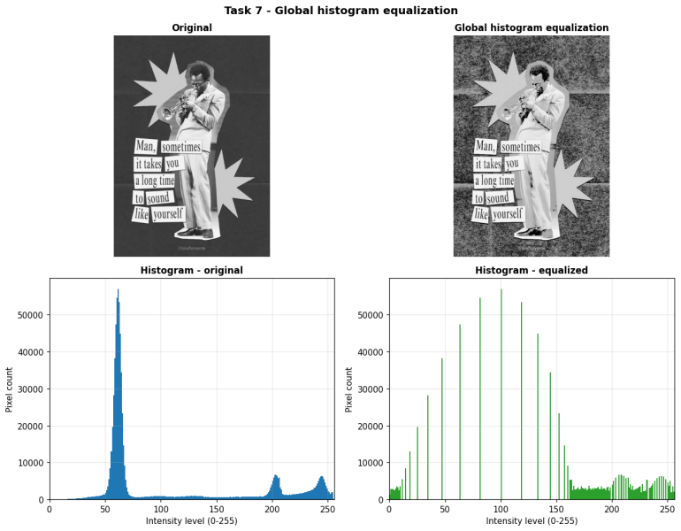
Figure 10 — Original vs globally equalized image, with histograms.
Observations — does detail improve? does noise grow?
- Detail: only marginally. The global contrast is unchanged (std 70.85 → 71.62) and the sparse mid-tones are stretched apart, but the bright elements (labels, stars, suit) are squeezed into the top of the range and the light areas look flatter. Only 103 of the 256 gray levels remain occupied — equalization spreads the levels apart and leaves gaps in the histogram.
- Noise: yes, much stronger. About 65 % of the pixels sit in a very narrow peak (levels ≈ 50–70), so the CDF is extremely steep there and equalization stretches this narrow band over a very wide range. The paper texture of the background becomes coarse grain: high-frequency energy rises from 14.41 to 30.36 (×2.11) and the std of a smooth 120 × 120 background patch rises from 3.18 to 42.54.
- For this image global equalization is therefore not an improvement; one mapping cannot treat the dark background and the bright elements differently, which motivates CLAHE (Task 8).

Task 8 — CLAHE
Parameters: clipLimit = 2.0, tileGridSize = (8, 8) — an 8 × 8 grid of 64 tiles (not 8 × 8 pixels per tile).
Method: cv2.createCLAHE(clipLimit=2.0, tileGridSize=(8, 8)).apply(img); an extra unevenly lit version (left 25 % → right 100 % illumination) is used to test local vs global enhancement.

Dry run 8 — histogram [6, 2, 0, 0], absolute cap 4
bin | original h | clipped | + excess/4 | new h' | cumulative | new CDF | old CDF | 255 x new CDF
0 | 6 | 4 | 0.5 | 4.5 | 4.5 | 0.5625 | 0.7500 | 143.44
1 | 2 | 2 | 0.5 | 2.5 | 7 | 0.8750 | 1.0000 | 223.12
2 | 0 | 0 | 0.5 | 0.5 | 7.5 | 0.9375 | 1.0000 | 239.06
3 | 0 | 0 | 0.5 | 0.5 | 8 | 1.0000 | 1.0000 | 255.00

✔ Verified in Python: New histogram [4.5, 2.5, 0.5, 0.5] (total 8); new CDF [0.5625, 0.875, 0.9375, 1.0].

Observation. Clipping the histogram [6, 2, 0, 0] at 4 gives [4, 2, 0, 0] with an excess of 2; sharing it equally adds 0.5 to each of the four bins → [4.5, 2.5, 0.5, 0.5] (total still 8). The new cumulative counts are 4.5, 7, 7.5, 8, so the new CDF is [0.5625, 0.875, 0.9375, 1.0], compared with the unclipped CDF [0.75, 1, 1, 1]. The first step is smaller (0.5625 instead of 0.75): the over-represented bin no longer dominates the mapping, which limits contrast (and noise) amplification.
Why neighbouring tile mappings need interpolation. Each tile computes its own mapping from its own histogram. If every pixel simply used the mapping of the tile it sits in, two adjacent pixels on a tile border would be transformed by different curves and a visible blocky seam would appear. CLAHE therefore bilinearly interpolates the mappings of the nearest tile centres for each pixel, giving a smooth result.
(Simplified model: OpenCV redistributes integer counts and its `clipLimit` is a multiple of the average bin height rather than an absolute cap.)

Image results
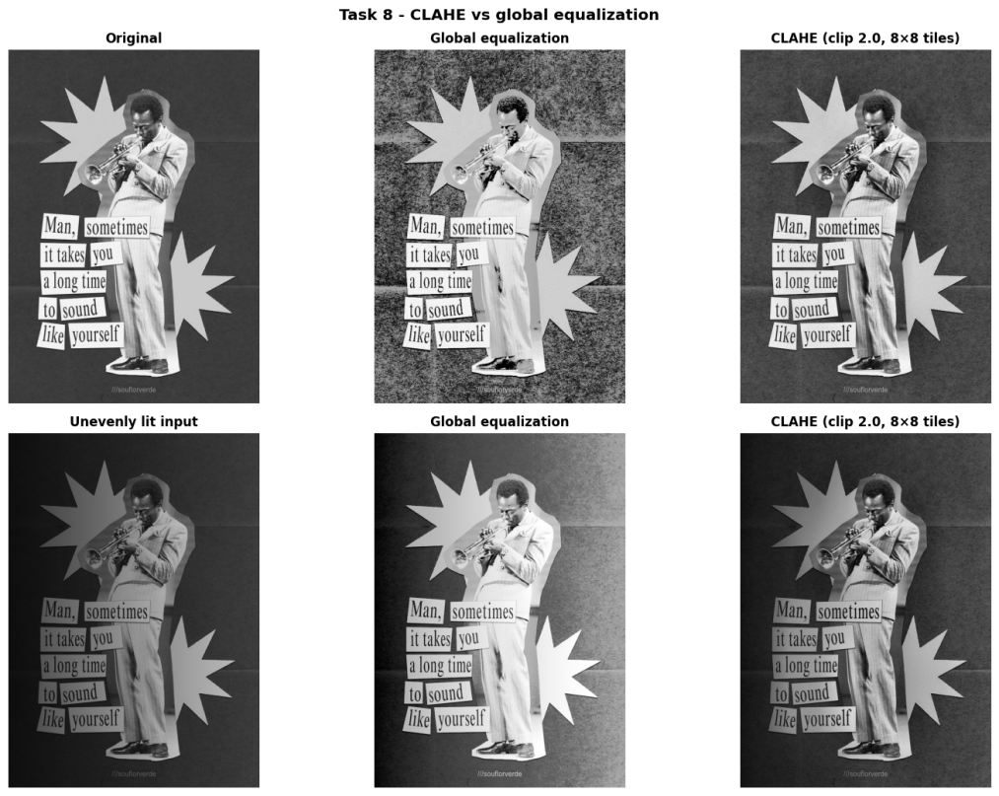
Figure 11 — Top: original image. Bottom: unevenly lit input. Columns: input, global equalization, CLAHE.
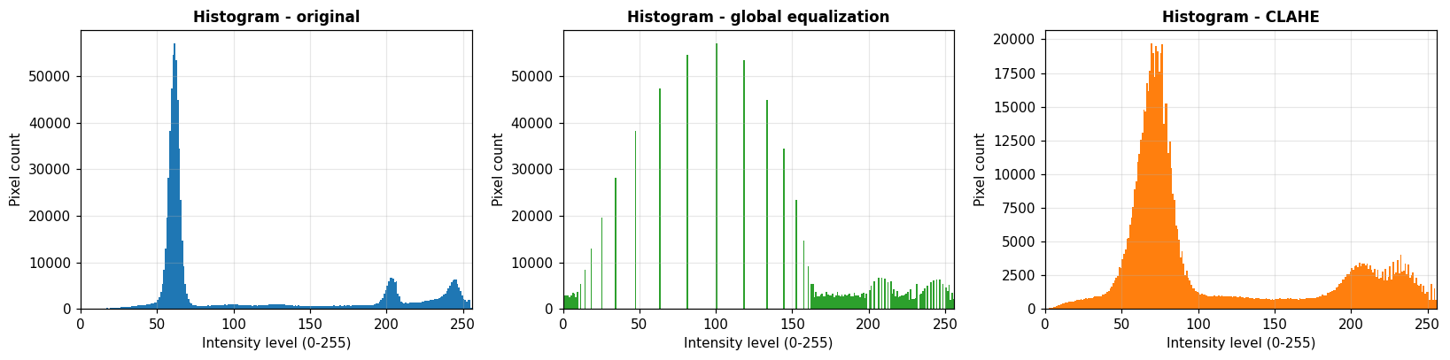
Figure 12 — Histograms: original, global equalization, CLAHE.
Unevenly lit image | Mean (left 1/3) | Mean (right 1/3) | |L − R| | Std (left) | Std (right)
Input | 39.16 | 66.44 | 27.28 | 33.00 | 35.19
Global equalization | 74.97 | 146.56 | 71.59 | 70.48 | 42.54
CLAHE | 55.83 | 77.44 | 21.61 | 44.28 | 38.29
Observations (CLAHE vs global equalization)
- tileGridSize = (8, 8) means an 8 × 8 grid of 64 tiles — here each tile is about 130 × 92 pixels (rows × columns) — it is not 8 × 8 pixels per tile.
- Original image: global equalization makes the background extremely grainy (see Task 7), whereas CLAHE with clipLimit = 2.0 gives a moderate contrast gain, keeps the paper texture subtle and keeps the figure's suit and the text clear. High-frequency energy: 14.41 (original), 30.36 (global), 16.04 (CLAHE) — the clip limit is what keeps CLAHE's noise amplification under control.
- Uneven lighting (left 25 % light → right 100 %): the left-to-right mean difference was 27.3 on the input; global equalization increased it to 71.6 (one mapping for the whole image cannot undo the illumination gradient), while CLAHE reduced it to 21.6 by adapting to each tile. CLAHE also restores readable contrast on the dark left side (e.g. the "Man, / it takes" labels).

Task 9 — Fixed Binary Thresholding
Rule: s = 255 if r > T, otherwise 0 (strict inequality).
Method: cv2.threshold(img, 127, 255, cv2.THRESH_BINARY).

Dry run 9 — pixels [0, 80, 127, 128, 180, 255]
r | r > 127 ? | output (T=127) | r > 180 ? | output (T=180)
0 | No | 0 | No | 0
80 | No | 0 | No | 0
127 | No | 0 | No | 0
128 | Yes | 255 | No | 0
180 | Yes | 255 | No | 0
255 | Yes | 255 | Yes | 255

Threshold | Output list | White pixels
T = 127 | [0, 0, 0, 255, 255, 255] | 3
T = 180 | [0, 0, 0, 0, 0, 255] | 1

✔ Verified in Python: Results identical to OpenCV for both thresholds.

Observation. With T = 127 the pixels 128, 180 and 255 are above the threshold → 3 white pixels; 127 itself is not greater than 127 and stays black. With T = 180 only 255 is above the threshold → 1 white pixel (180 > 180 is false). Raising the threshold removes white pixels (3 → 1). OpenCV gives identical results.

Image results
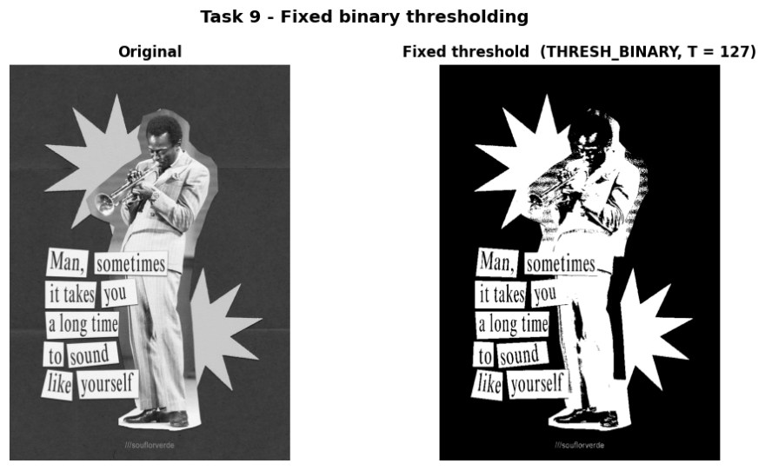
Figure 13 — Original and fixed-threshold binary image (T = 127). Unique values: 0 and 255.
Observations
Observations. The binary image contains only the two values [0, 255]. With T = 127, 29.85 % of the pixels are white. Because the background (≈ 61) is far below 127 and the labels, stars and light suit are far above it, the result is a clean silhouette of the figure, text labels and stars on black; the dark parts of the figure (hair, shoes, shadowed clothing) fall below T and merge with the background, and all mid-tone detail is lost because each pixel is forced into one of two classes by a single, manually chosen threshold.

Task 10 — Otsu Thresholding
Criterion: maximise σB²(T) = w0·w1·(μ0 − μ1)², classes r ≤ T and r > T; ties → smallest T.
Method: cv2.threshold(img, 0, 255, cv2.THRESH_BINARY + cv2.THRESH_OTSU); an independent NumPy implementation is used as a cross-check.

Dry run 10 — pixels [0, 1, 4, 5] (no rescaling)
T | class0 (r<=T) | class1 (r>T) | w0 | w1 | mu0 | mu1 | sigma_B^2
0 | [0] | [1, 4, 5] | 1/4 | 3/4 | 0 | 10/3 | 25/12 = 2.0833
1 | [0, 1] | [4, 5] | 1/2 | 1/2 | 1/2 | 9/2 | 4 = 4.0000
2 | [0, 1] | [4, 5] | 1/2 | 1/2 | 1/2 | 9/2 | 4 = 4.0000
3 | [0, 1] | [4, 5] | 1/2 | 1/2 | 1/2 | 9/2 | 4 = 4.0000
4 | [0, 1, 4] | [5] | 3/4 | 1/4 | 5/3 | 5 | 25/12 = 2.0833

✔ Verified in Python: Maximum σB² = 4 at T = 1, 2, 3 → choose T = 1; predicted mask [0, 0, 255, 255]; OpenCV returns T = 1.0 and the same mask.

Observation. σ_B²(T) = w0·w1·(μ0 − μ1)²: T = 0 → 25/12 ≈ 2.0833; T = 1, 2, 3 → 4 (all three give the same split {0, 1} | {4, 5}, because no pixel has the value 2 or 3); T = 4 → 25/12 ≈ 2.0833. The maximum is tied at T = 1, 2, 3, so the smallest, T = 1, is chosen. Since the rule is r > T, the predicted mask is [0, 0, 255, 255]. OpenCV returns T = 1.0 and the same mask, so the prediction is verified.

Image results
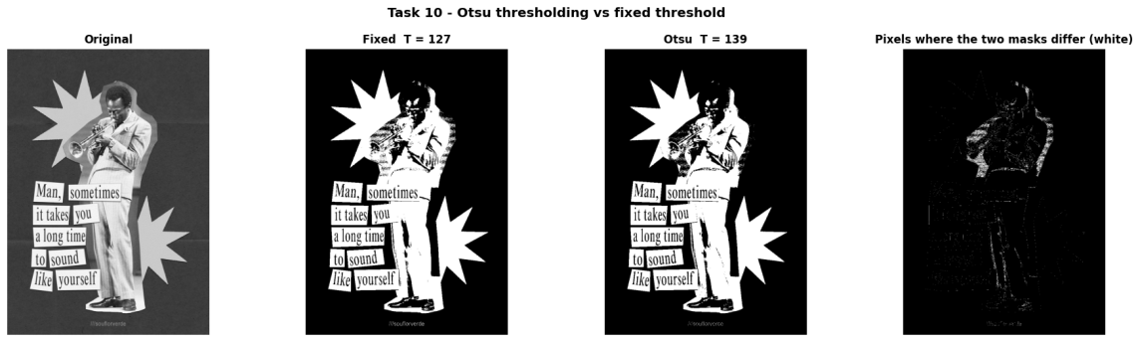
Figure 14 — Fixed (T = 127) vs Otsu (T = 102) masks and the pixels where they differ.
Method | Threshold | White pixels (%)
Fixed | 127 | 29.85
Otsu (OpenCV) | 139 | 28.47
Agreement of the two masks | — | 98.62 %
Observations
- OpenCV's Otsu returned T = 139, and an independent NumPy implementation of the between-class-variance formula gave the same value.
- Otsu's mask has 28.47 % white pixels versus 29.85 % for the fixed T = 127; the two masks agree on 98.62 % of the pixels (10,588 pixels differ). By construction the masks can only differ on pixels with intensity 128–139 — these are the white pixels in the difference image (edges and light-gray areas of the clothing and stars).
- The two masks are almost identical because the histogram has a wide, almost empty valley between the dark background peak (61) and the bright peaks (≈ 203 and 244): any threshold in that valley gives nearly the same segmentation. Otsu picks its threshold automatically from the histogram, whereas 127 is an arbitrary fixed value; both are global thresholds.

Task 11 — Adaptive Gaussian Thresholding
Rule: T(x, y) = Gaussian-weighted local mean − C; s = 255 if r > T. Parameters: blockSize = 11, C = 2.
Method: cv2.adaptiveThreshold(img, 255, ADAPTIVE_THRESH_GAUSSIAN_C, THRESH_BINARY, 11, 2). The 3 × 3 window below is only for the dry run.

Dry run 11 — 3 × 3 neighbourhood with Gaussian weights [[1,2,1],[2,4,2],[1,2,1]]/16
row | col 1 | col 2 | col 3 | row sum
1 | 100 x 1/16 = 6.2500 | 100 x 2/16 = 12.5000 | 100 x 1/16 = 6.2500 | 25.0000
2 | 100 x 2/16 = 12.5000 | 120 x 4/16 = 30.0000 | 140 x 2/16 = 17.5000 | 60.0000
3 | 140 x 1/16 = 8.7500 | 140 x 2/16 = 17.5000 | 140 x 1/16 = 8.7500 | 35.0000

Step | Calculation | Result
Weighted mean | (400 + 960 + 560) / 16 = 1920 / 16 | 120
Local threshold | T = mean − C = 120 − 2 | 118
Centre pixel r = 120 | 120 > 118 ? true | Output 255
Pixel equal to T (r = 118) | 118 > 118 ? false (strict) | Output 0

✔ Verified in Python: OpenCV (blockSize = 3, C = 2) returns 255 for the centre 120 and 0 for a centre equal to T.

Observation. Weighted sum = (100 + 200 + 100 + 200 + 480 + 280 + 140 + 280 + 140)/16 = 1920/16 = 120, so T = 120 − 2 = 118. The centre pixel 120 > 118 is true → output 255. A pixel equal to T (118) fails the strict test 118 > 118, so it becomes 0. OpenCV confirms both cases (centre 120 → 255; a centre equal to T → 0) on a 3 × 3 block with the same Gaussian weights.

Image results
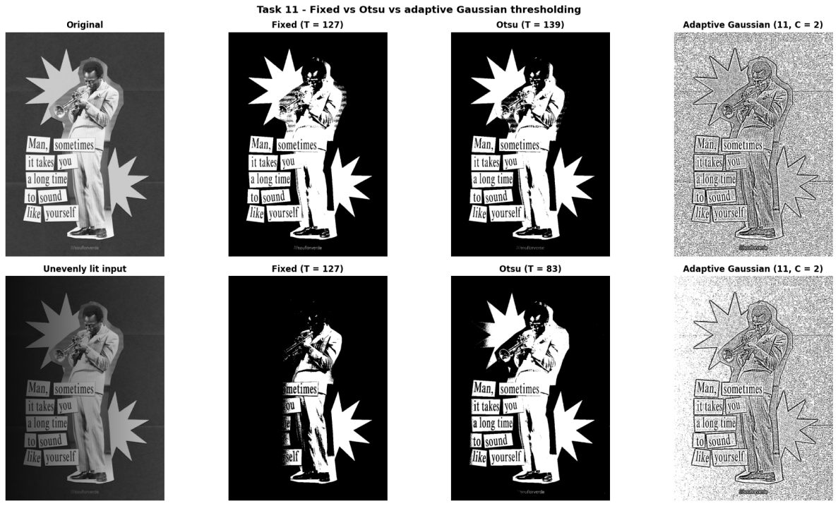
Figure 15 — Top: normal image. Bottom: unevenly lit image. Columns: input, fixed, Otsu, adaptive Gaussian.
Method | White % (original) | White % (uneven) | Left third white % | Right third white %
Fixed T = 127 | 29.85 | 13.51 | 0.00 | 10.77
Otsu | 28.47 | 28.19 | 20.81 | 12.87
Adaptive Gaussian | 68.36 | 76.11 | 86.31 | 74.54
Observations (adaptive Gaussian, blockSize = 11, C = 2)
- On the normal image the adaptive result keeps only local edges and outlines (the figure, the text and the star boundaries) and turns the flat background into noisy speckle (68.36 % of the pixels white overall), because on flat paper the local mean − 2 sits right at the noise level. For this high-contrast, bimodal image the global methods (fixed and especially Otsu) give the cleaner and more useful mask.
- On the unevenly lit image the fixed T = 127 fails: the dark left third has 0.00 % white pixels (the white labels "Man, / it takes / a long time" on the left are lost — see Figure 15), and only the bright right side survives. Otsu adapts its threshold to the darker histogram (T = 83) and still separates the labels; the adaptive threshold shows structure on both sides (86.31 % and 74.54 % white in the left and right thirds), although still with background speckle. (The thirds contain different image content, so the white percentages show the failure of the fixed value rather than a precise lighting measure.)
- When local thresholds help: strong illumination gradients, shadows and low-contrast text such as scanned or photographed documents. When the foreground/background histogram is clearly bimodal and the lighting is uniform, as in this image, a global (Otsu) threshold is simpler, faster and less noisy.

12. Explanations Required by the Lab

Clipping
A transform can produce values outside 0–255 (e.g. 240 + 40 = 280 or 30 − 40 = −10). Clipping forces them to the nearest legal level (255 or 0). It prevents wrap-around but destroys information: all pixels clipped to 255 (or 0) become indistinguishable. In this lab +40 saturated 14.16 % of the pixels and −40 crushed 1.31 % to black; s = 1.5 r saturated 25.93 %.

Overflow
uint8 arithmetic wraps modulo 256, so 240 + 40 becomes 24 instead of 255 and bright pixels turn dark. It is avoided by converting to a wider type (int16 / float64), computing, clipping to 0–255, and only then converting back to uint8 (truncating fractions).

Brightness versus contrast
Brightness (s = r + β) shifts every intensity by the same amount and leaves the spread unchanged until clipping occurs. Contrast (s = αr or s = (r − 128)α + 128) scales the spread: α > 1 widens differences between pixels, α < 1 narrows them. Scaling from zero also changes the mean brightness (107.23 → 140.98 for α = 1.5), whereas scaling about the pivot 128 mainly changes the spread (mean 91.40, std 96.15).

Gamma convention
This lab uses s = 255·(r/255)^γ: γ < 1 brightens (it expands the dark range), γ > 1 darkens (it compresses the dark range), and 0 and 255 always stay fixed. Some libraries and slides use s = 255·(r/255)^(1/γ), which reverses the direction of γ, so the convention must always be stated.

When are global or local methods useful?
- Global enhancement / thresholding (histogram equalization, fixed and Otsu thresholds) is fast and works well when lighting is uniform and the histogram represents the whole image — e.g. Otsu on a clearly bimodal image.
- Local enhancement / thresholding (CLAHE, adaptive thresholding) copes with shadows, vignetting and uneven illumination (Figures 11 and 15), at the price of extra computation, more parameters (tile size, clip limit, block size, C) and stronger local noise amplification.

13. Summary of Results
# | Operation | Key measured result
1 | Brightness ±40 | Mean 107.23 → 143.91 / 67.36; clipped 14.16 % (white) / 1.31 % (black); loops = NumPy
2 | s = 1.5 r | Mean → 140.98; 25.93 % of pixels saturated at 255
3 | Centred contrast | α = 1.5: std 96.15, 1.77 % at 0; α = 0.5: std 35.43; pivot 128 fixed
4 | Negative | Exactly invertible (negative of negative = original)
5 | Gamma | Dark-region mean 58.33 → 121.11 (γ = 0.5) / 13.07 (γ = 2.0); 0 and 255 fixed
6 | Histogram | Dominant dark peak at 61; 65.50 % of pixels in 0–84; 5th–95th percentile 54–244
7 | Global equalization | Std 71.62; 103 levels used; high-frequency energy 14.41 → 30.36
8 | CLAHE | Left/right mean gap on uneven image: 27.28 (input), 71.59 (global), 21.61 (CLAHE)
9 | Fixed threshold | T = 127; 29.85 % white; values {0, 255}
10 | Otsu | T = 139; 28.47 % white; agrees with fixed mask on 98.62 % of pixels
11 | Adaptive Gaussian | 68.36 % white; on uneven image left/right white 86.31 % / 74.54 % (fixed: 0.00 % / 10.77 %)

Requirement checklist
# | Operation | Dry run | Image experiment | Python verification
1 | Brightness ±40 (+ nested loops) | ✔ | ✔ | ✔
2 | Linear contrast s = 1.5 r | ✔ | ✔ | ✔
3 | Contrast centred at 128 (α = 1.5, 0.5) | ✔ | ✔ | ✔
4 | Image negative | ✔ | ✔ | ✔
5 | Gamma correction (γ = 0.5, 2.0) | ✔ | ✔ | ✔
6 | Grayscale histogram (256 bins) | ✔ | ✔ | ✔
7 | Global histogram equalization | ✔ | ✔ | ✔ (vs OpenCV)
8 | CLAHE (clip 2.0, 8×8 tiles) | ✔ | ✔ | ✔
9 | Fixed binary thresholding (T = 127) | ✔ | ✔ | ✔ (vs OpenCV)
10 | Otsu thresholding | ✔ | ✔ | ✔ (vs OpenCV)
11 | Adaptive Gaussian thresholding | ✔ | ✔ | ✔ (vs OpenCV)

Conclusion. Point operations (brightness, contrast, negative, gamma) are simple look-up transformations whose main danger is overflow and clipping; histogram methods redistribute intensities globally or locally, and thresholding converts the image to a mask either with one global value (fixed, Otsu) or with a locally computed value (adaptive). All eleven hand calculations were reproduced exactly in Python and, where an OpenCV function exists, matched its output.

